Accreditation requirements ISO/IEC 17065:2012 |  | Target population
Object:  At the end of this training the participants will able to:  - Identify and acquire knowledge of the requirements of ISO 17065  - Develop skills for the best way to participate actively in the implementation and maintain the quality management system. |  | Quality Manager  technical Manager  Evaluators  Pilot process  …
Trainer
Mr Ridha BEDHIEF
Period
3 Days
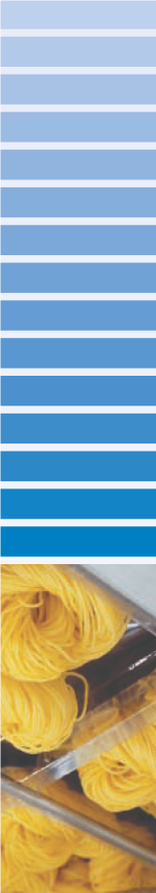
Course Program: Requirements of ISO 17065
DOC/FRM/01-535-V01

Day | Time | Program
Day 1 :  Monday, February 17, 2014 | From  08 :30 am to 10 :00am | - Introduction:  - The quality management system  - Principles of Quality Management  - ISO 17065 Standards.  - General presentation and Particularities  - ISO / IEC 17020
Day 1 :  Monday, February 17, 2014 | From 10 :00am to 10 : 30am | Break
Day 1 :  Monday, February 17, 2014 | From 10 :30am to 12 : 00am | - Understanding the general and organizational requirements :  - Legal and contractual matters  - Management of impartiality  - Liability and financing  - Non-discriminatory conditions
Day 1 :  Monday, February 17, 2014 | From 12 :00am to 01 : 00pm | Break
Day 1 :  Monday, February 17, 2014 | From 01 :00pm to 03 : 00pm | - Understanding the general and organizational requirements (cont’d) :  - Confidentiality  - Publicly available information  - Organizational structure and top management  - Mechanism for safeguarding impartiality
Day 2:  Tuesday, February 18, 2014 | From  08 :30 am to 10 :00am | - Presentation of the requirements for resource :  - Certification body personnel  - Resources for evaluation
Day 2:  Tuesday, February 18, 2014 | From 10 :00am to 10 : 30am | Break
Day 2:  Tuesday, February 18, 2014 | From 10 :30am to 12 : 00am | - Presentation of technical requirements:  - Application  - Application review  - Evaluation  - Review
Day 2:  Tuesday, February 18, 2014 | From 12 :00am to 01 : 00pm | Break
Day 2:  Tuesday, February 18, 2014 | From 01 :00pm to 03 : 00pm | - Presentation of technical requirements (cont’d):  - Certification decision  - Certification documentation  - Directory of certified products  - Surveillance
Day 3 :  Wednesday, February 19, 2014 | From  08 :30 am to 10 :00am | - Presentation of technical requirements (cont’d) :  - Changes affecting certification  - Termination, reduction, suspension or withdrawal of certification  - Records  - Complaints and appeals
Day 3 :  Wednesday, February 19, 2014 | From 10 :00am to 10 : 30am | Break
Day 3 :  Wednesday, February 19, 2014 | From 10 :30am to 12 : 00am | - Presentation requirements for management:  - Options  - General management system documentation  - Control of documents  - Control of records
Day 3 :  Wednesday, February 19, 2014 | From 12 :00am to 01 : 00pm | Break
Day 3 :  Wednesday, February 19, 2014 | From 01 :00pm to 03 : 00pm | - Presentation requirements for management (cont’d):  - Management review  - Internal audits  - Corrective actions  - Preventive actions

